Started: 1:30
Attendees:
- Rima Abusaid: rabusaid@illinois.edu
- Arianna: ariannan@cahokialibrary.org
- Lauren Landfried: Lauren.landfried@health.slu.edu
- Hannah Gravot: hcgravot@illinois.edu
- Jen Zuercher: jzuerch@siue.edu
- Tiffany Davis: tiffanyd@healthiertogether.net
- Grace Margherio: gracem@illinois.edu
- Caroline Mitchell: caroline.mitchell@gwrymca.org
- Olivia Middendorf: Omiddendorf@eshd.org
- Viktoria Zolman: vzolman.pha@gmail.com
- YaYa McKay: yaya1boy@gmail.com

Check in With Garden:
-Lalumier: Water has been shut off for three weeks now, the parking lot is having construction, and troubles with getting volunteers. The garden is trying to plan volunteer events and possibly having a back to school event if the water comes back on.
-Cahokia Library: No water, was having troubles with using rain barrels because of lack of rain, and wasps nests are forming around the water jugs. With the funds, has bought two self watering boxes for the garden and is about to put greens beds in place.
- Arianna Can help post flyers for gardens and has flowers to give out.
-East Side Health District: Doing very well, has a Farmers Market that is opening up outside of the East Side Health District Building and is giving out coupons for the market. The market starts July 13th and is continuing every Thursday 9am-Noon for the summer and fall season.
-Jackie Joyner Kersee Center: The Farmers Market is opening up soon as well, birds are starting to get to the sweet corn, and the tomatoes are starting to have some issues.
-Midwest Clean Food and Water Movement: Is setting up Aquaponics, Fish Farms, wants to hold classes for lessons on Aquaponics, has meetings to secure the land around the garden for Solar Islands, and has a partnership with Seed St. Louis.
- YaYa is looking for recommendations for 10 foot fencing around the garden.

Master Gardener Training:
- Recruitment
- Next Training in the Fall
- Information being sent out at the end of July
- Dr. Z - interested in the training

Grant For Fruit Trees:
https://www.ftpf.org/apply
Volunteer Accelerator Program
· You (or your volunteer point person) can fill out this Google Form with your opportunities.

Garden Log:
-Highlights challenges, achievements, how much is harvested, how many beds are in place, and photos. It will be an ongoing document that everyone will be able to access and add updates on their gardens as the months progress.
- Link to Add Garden Updates: Success Stories Garden

Partner Updates:
-Americorps Service Member Highlight: Lalumier Garden
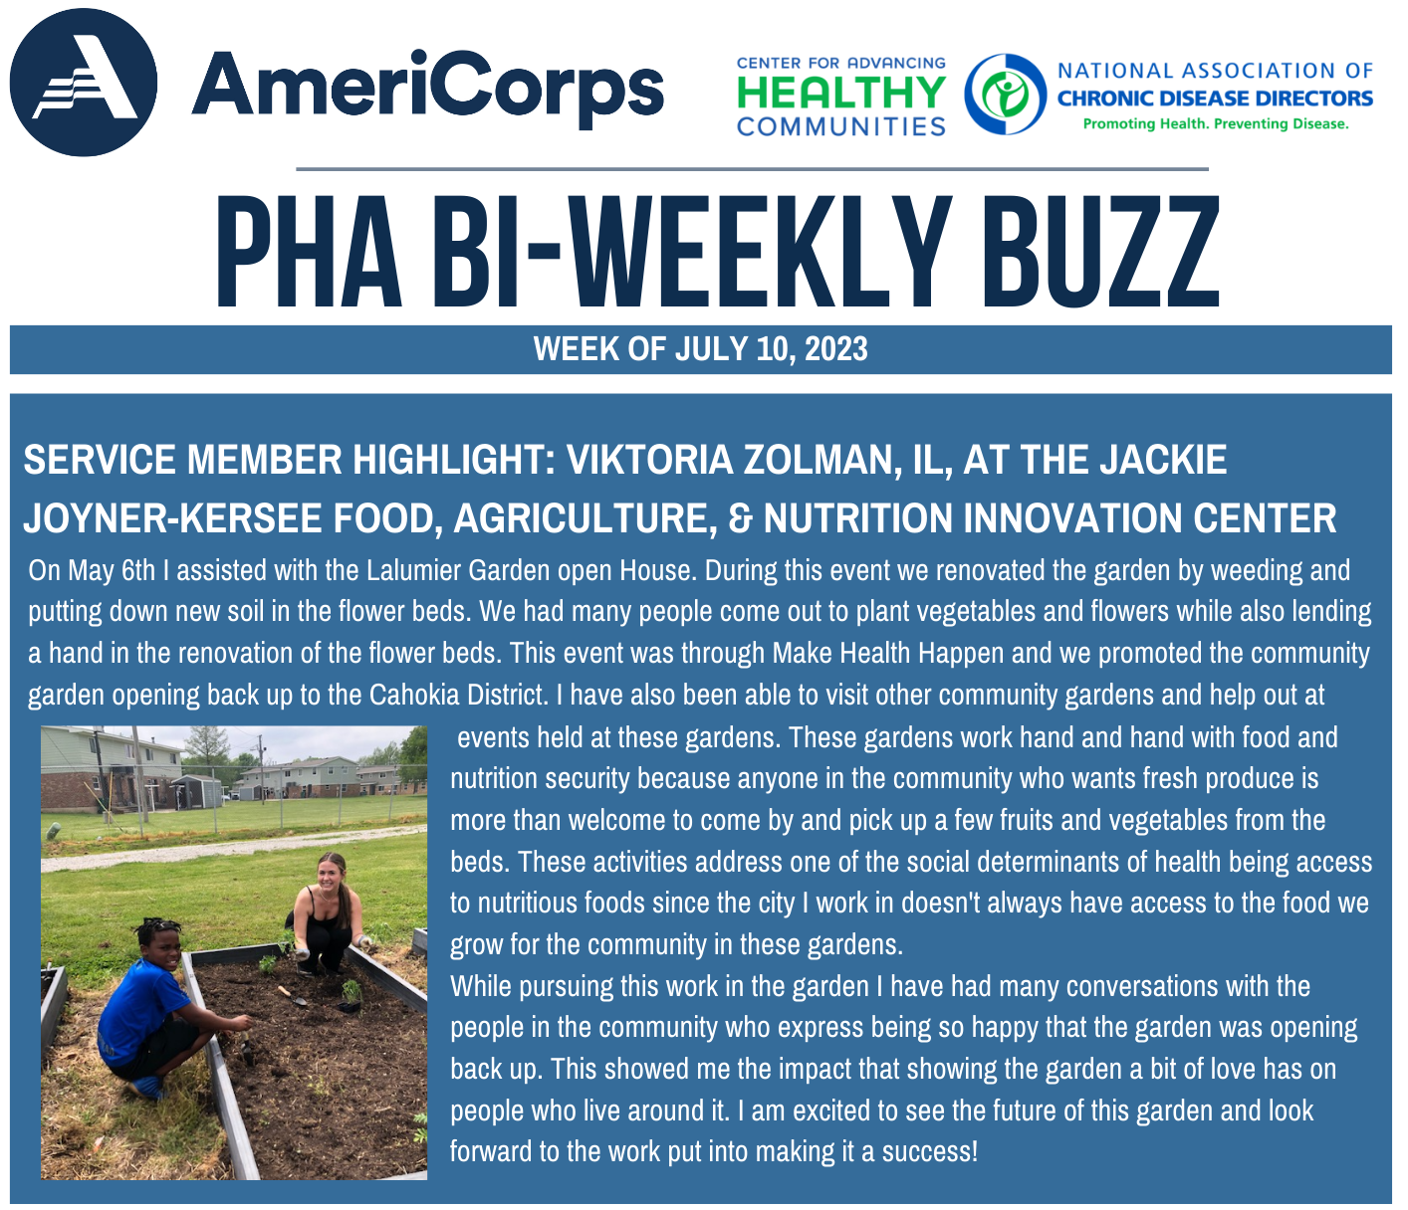

Ended: 2:13pm

